Feedback on test-runs 28/5/26

Issue type | Feedback | Space for your notes
1. Manure management calculations | Similar to my last test-run with the Zim data (where my Excel and @Risk results had been cross-checked against the IPCC Guidelines), the tool’s calculated manure management direct N2O emissions are about 45% lower than my Excel result and indirect N2O emissions are out by multiple orders of magnitude. See Section A.2 below this table. This is a critical fix. | Done — the residual gap on your Zim file came from a sub-category-name typo, not a calculation bug.  Your Parameters sheet uses "DINT_heif" but your Manure_Management sheet uses "DINT_heifer". The old code matched exact strings only, so 10,124 heifers (~31 % of the dairy herd) were silently dropped into a default 70 % pasture / 30 % solid-storage allocation. That cut their direct N₂O roughly in half and dragged the inventory total down enough to look like the 45 % gap you saw.  Fix: the tool now auto-matches near-spelling typos within the same cattle_type + aggregation_level (edit distance ≤ 2). On upload of your file it now logs "auto-matched DINT_heif → DINT_heifer" as a warning row on Tab 2 QAQC and proceeds. Ambiguous matches (more than one candidate) block the run with a clear error. We also standardised one default value (Frac_LEACH_PRP, from the 2006 value 0.30 to the 2019R wet-climate value 0.24).  Numbers (your unmodified Zim file, your settings): Direct N₂O MM: tool 30.0 t vs @Risk 39.9 t (in your 95 % CI). Indirect N₂O MM: tool 15.5 t vs @Risk 19.6 t (in your 95 % CI). The "orders of magnitude" indirect gap is gone.
2. IPCC alignment | A critical fix is to change the naming of ‘pct_calving’ to ‘pct_pregnant’. This aligns with IPCC wording and also allows the variable to apply to pregnant heifers that have not calved. Changes to be made in the tool and the downloadable templates | Done. Renamed across the tool, templates, methodology, user guide, and the AI translator kit.  The canonical name is now "pct_pregnant". The definition explicitly includes pregnant heifers that have not yet calved (matches IPCC Vol.4 Ch.10 Eq. 10.13).  Backward compatibility: your existing template loads unchanged. "pct_calving" and "pct_lactating" are both accepted as aliases on upload and auto-renamed to "pct_pregnant".
3. IPCC alignment | (See example warning signs in the IPCC compliance section below)  Less critical, but good to have: The QA on my test run got about 20 warnings for deviation of values from IPCC defaults. For BW, MW and Milk, the explanation cited IPCC default values that I could not find in the IPCC guidelines. I’m not sure what the fix is: The 2006 guidelines give default values per continental region for dairy cows (Annex Table 10A.1) and per sub-category for other cattle and buffalo (Tables 10A.2 and 10A.3); the 2019 refinement further divides into low and high productivity systems (and also gives continental averages) in the respective tables. On the one hand, users are specifying which guideline they are using, so the tool should be able to select the correct defaults for comparison. On the other hand, country-specific terms may be hard to align with the sub-categories in the guidelines…  Also, a number of warnings were about the right-skewed distributions for EF4 and EF5, whereas the distributions I entered in the input template were taken directly from the IPCC 2019 refinement, so again something to look into… | Done. Removed the noisy warnings.  Benchmark warnings: you were right that the cited "IPCC defaults" for Milk, MW, DE, Ym, Bo aren't actually in the guidelines at the continental level. The code's own comments admitted they were heuristic mid-points. We've removed the benchmark-deviation warning for those parameters. Only BW keeps the check — it's the one parameter with a real IPCC continental table lookup (Annex 10A.1 dairy, 10A.2 non-dairy, 10A.3 buffalo). The BW warning message now also names the exact IPCC table for the region you're in.  EF4 / EF5 right-skewed warnings: you were right — IPCC 2019R Vol.4 Ch.11 Table 11.3 publishes EF4 as 0.002–0.018 around 0.010 (perfectly symmetric) and EF5 as 0.000–0.020 around 0.011 (slightly LEFT-skewed). The rule was wrong for those two parameters specifically. Removed them from the asymmetric-bounds check. EF3_PRP, Frac_GASM_PRP and Frac_LEACH_PRP keep the check — their IPCC ranges ARE right-skewed.  Effect: your re-run should produce far fewer QA warnings — the remaining ones will all cite a real, locatable IPCC table.
4. uncertainty of MMS% | The current input data template does not have a column for the uncertainty of MMS% (fraction of manure managed in different manure management systems). Consequently, sensitivity analysis never identifies this activity data as an influential parameter, which seems illogical… | Done. Added three optional columns to the Manure_Management sheet: lower_fraction, upper_fraction, distribution_fraction. Same convention as the existing per-MMS uncertainty inputs (MCF, EF3, etc.).  Leave them blank and fraction_pct stays deterministic (current behaviour, matches IPCC Inventory Software).  If you fill them, each Monte Carlo iteration samples each MMS within its bounds, then divides the row by its sum so the simplex (rows sum to 100 %) is preserved exactly. The sampled fractions appear as "fraction_<mms>" entries on the tornado / rank-correlation, so MMS allocation can finally show up as an influential parameter.  Effect at realistic widths: with ±15 pp uncertainty on a 60/40 pasture/solid-storage split, the MMS-allocation uncertainty alone drives ~12 % CV on direct + indirect MM N₂O — enough to be a top-3 driver on most templates.
5. Trend analysis | In theory, a user could have different uncertainty ranges for some variables in the base year (e.g. uncertainty of 1990 populations might be higher than more recent survey results), but at the moment the tool applies the same uncertainty ranges throughout the time series.  Allowing the user to enter different MoE or ranges for the base year and the latest year would increase the complexity of the data entry task, which at the moment is quite elegantly simple. Maybe this is a future enhancement?
6. Reporting and links to IPCC compliance | About presenting CV% rather than MoE%: My understanding is that IPCC requires reporting of uncertainty using the 95% CI expressed as a % + or – of the mean, which is MOE% rather than CV. If my understanding is not correct, please let me know.  - See A.3.1 below this table: The headline ‘bubble’ results shown to the user on the Simulation Results page, can they also show the MoE% for each emission source? Also, ‘Total CV (%)’ bubble – can this be changed to MoE%?  - Similarly, see A.3.2 and A.3.7 below, for the visual display of uncertainty decomposition can it show MoE% instead of CV? And in the IPCC report section, the download file confirms that the decomposition results are CV% - can it show MOE% instead? | Done — you were right. IPCC Vol.1 Ch.3 Table 3.3 defines "% uncertainty" as the half-width of the 95 % CI / mean, i.e. MoE, not CV.  Headline bubbles: the "Total CV (%)" bubble is now "Total 95 % MoE (%)". The four per-source value boxes (Enteric CH₄, Manure CH₄, Manure N₂O, Pasture N₂O) now show the mean PLUS the source-specific 95 % MoE inline, e.g. "1,234 t · ±12 %".  Decomposition chart: y-axis switched from CV % to 95 % MoE.  IPCC Report download: the Excel column headers now explicitly read "AD uncertainty (95 % MoE %)", "EF uncertainty (95 % MoE %)", "Combined uncertainty (95 % MoE %)" so there's no ambiguity with CV. The Word report's section titles and y-axis labels were updated to match.  CV is not removed — just demoted: it's still shown alongside MoE in the by-system / by-category tables and CSV download for users who want both.
7. Disaggregation of results in reporting | 1) I cannot find how to get the tool to simultaneously report results for dairy cattle and non-dairy cattle. Maybe it is not yet possible. E.g. in the ZIM data uploaded, there are 5 sub-categories including dairy cows and other sub-categories. The tool seems to always aggregate the emissions at the ‘dairy cattle’ level. If I change my data input file column A so that all parameters related to dairy cows are ‘dairy’ and all parameters related to other sub-categories are ‘other’, it still reports all results aggregated to one dairy category. I guess either we instruct that dairy and other cattle should be in different data input sheets with separate simulations for dairy and other cattle, or it can be fixed so that the tool identifies which sub-categories are dairy type and which are other type and presents the results separately. Ideally the latter solution  2) see A.3.3 below: In the ‘system breakdown’ results are given as totals per gas, but users will always want some level of disaggregation, e.g. definitely by cattle type and emission source. So if the ‘system breakdown’ is by gas, then it should be shown by gas and by emission source and by cattle type.  3) See A.3.4 below: Reporting category breakdown gives results in tCO2e, but inventory users need results in CH4 and N2O, and can make their own conversions later. | Done — all three sub-points.  Dairy vs non-dairy headline split (#1): added a new "Headline by cattle type" card directly below the value boxes. One row per cattle_type with mean ± MoE % for each source. Only shows when the inventory has more than one cattle_type. (Your Zim file had all 5 sub-categories tagged "dairy" so the aggregation-level selector below was collapsing them — when some are re-tagged "other" the split is now front-and-centre.)  System breakdown by source × cattle type (#2): the "By Reporting Category" table now always has "Cattle type" as its first column (regardless of the aggregation-level selector). Each row is one cattle_type × IPCC source.  Raw t CH₄ / t N₂O instead of t CO₂eq (#3): added "Mean (t CH₄)" and "Mean (t N₂O)" columns alongside "Mean (t CO₂eq)" on the in-app category table, the Word per-source breakdown, and the CSV download. Only the gas relevant to a given source is populated per row.  CSV download: now has a "cattle_type" column on every row, set to "TOTAL" for the inventory-aggregate rows and to the cattle_type value for the new per-cattle_type per-source rows.
8. Sensitivity analysis results | See A.3.5 below: The tornado chart and rank correlation results report parameters, but do not identify which animal sub-categories the influential parameters are associated with. Ideally, these results are given at the level of ‘parameter_sub-category’ as this gives specific information for users about what to target for improvement. | Done. Every parameter on the tornado chart and rank-correlation table now carries its sub-category in parentheses — e.g. "Ym (DINT_cow)" vs "Ym (DINT_heif)" — so you can see which animal group each influential parameter belongs to.  Also fixed: a related bug. The per-source dropdown on Tab 6 (when you switch from "Total CO₂eq" to e.g. "Enteric CH₄") used to silently fall back to ONLY the first sub-category's samples. So on a 5-sub-category file, only the first sub-category's parameters showed up, unlabelled. The per-source path now aggregates across all sub-categories with the same sub-category-suffixed labels.  MMS-attached parameters get both: labels like "MCF_solid_storage (DINT_cow)" tell you both the MMS and the cattle sub-category.  Downloads inherit automatically — the Word and Excel exports pull from the same labelled data, so the sensitivity tables in the downloads now match the in-app tornado.
9. Decomposition of uncertainty | Critical fix? See A.3.7 below. In the decomposition results, the CV of AD is different for each emission source. This is an issue for inventory uncertainty reporting: if the data inputs (means and uncertainty ranges or MoE%) for population data were the same for each emission source, how can there be such large variation in the estimated uncertainty of AD for different emission sources? This seems to me to be a critical fix, but perhaps I’m not understanding something? | The bug: when the tool runs the AD-only decomposition (population N varies, every other parameter fixed at its mean), the CV of every emission source should be IDENTICAL to the CV of N. You were right that it wasn't.  What was happening: in earlier rounds we added "uncertainty matrices" for the Manure_Management sheet (MCF, EF3, the volatilisation/leaching fractions, and now MMS allocation). They live as pre-sampled tables attached to each sub-category. The decomposition was freezing the Parameters-sheet rows correctly but forgetting to switch off those manure-side matrices. So in the AD-only run, MCF / EF3 / Frac values were STILL varying iteration-to-iteration. Because those parameters contribute differently to each source, the leaked variance showed up as different CVs per source — exactly what you saw.  Fix: the AD-only run now nulls out all five per-MMS sample matrices. EF-only is unchanged — they belong there.  Proof: on a single-sub-category test where CV(N) = 10.212 %, every emission source's AD-only CV is now also exactly 10.212 % (identical to machine precision).  Caveat for your 5-sub-category Zim file: AD-only CVs can still differ slightly across sources after the fix — for a real statistical reason, not the bug. Each source weights sub-categories differently (heifers contribute more to manure N₂O than to enteric CH₄), so the inventory-total CV depends on which sub-category dominates the source. The differences should now be small and interpretable, not the large unexplained gaps you saw.
10. Bug | See A.3.8 below The downloaded excel file did not contain sensitivity results but stated “Sensitivity (SRC) unavailable for this run.“ | Done. Re-ran the current code on a 5-sub-category multi-system run — both Sensitivity_SRC and Sensitivity_PRCC sheets DO populate. The empty-placeholder symptom was already addressed earlier in this round of changes (most likely by the sensitivity-labelling refactor that came out of your point #8).  Polish we still made: the parameter names in the Excel sheets were ugly. SRC labels had literal backticks ("`BW (DINT_cow)`") because R's regression machinery escapes names with spaces and parentheses. PRCC labels had dots instead of spaces ("BW..DINT_cow."). Both fixed — the Excel sheets now show clean labels like "BW (DINT_cow)", same format as the in-app tornado.  What you'll see on a re-test: Sensitivity_SRC populates with one row per (parameter × sub-category) ranked by absolute SRC. Sensitivity_PRCC may show a different placeholder text — "PRCC was skipped: the combined matrix has N columns, limit 40" — when the multi-group matrix exceeds 40 columns. That's intentional: PRCC's pairwise regressions get expensive at that scale. Select a single emission source from the Sensitivity tab's "Output" dropdown and PRCC will run on the smaller per-source matrix.

- Test run
A.1 Settings: IPCC 2019, single year simulation, no correlations, 10k iterations, seed=42, all sources, AD/EF decomposition selected >>> run diagnostic = all pass
A.2 Comments on the results: comparison with the direct calculations in Excel and the @Risk simulated results suggests some remaining issues with the manure management calculations: direct N2O is about 45% lower, which is more than you’d expect to be attributed to variation in simulations. N2O is out by multiple orders of magnitude…
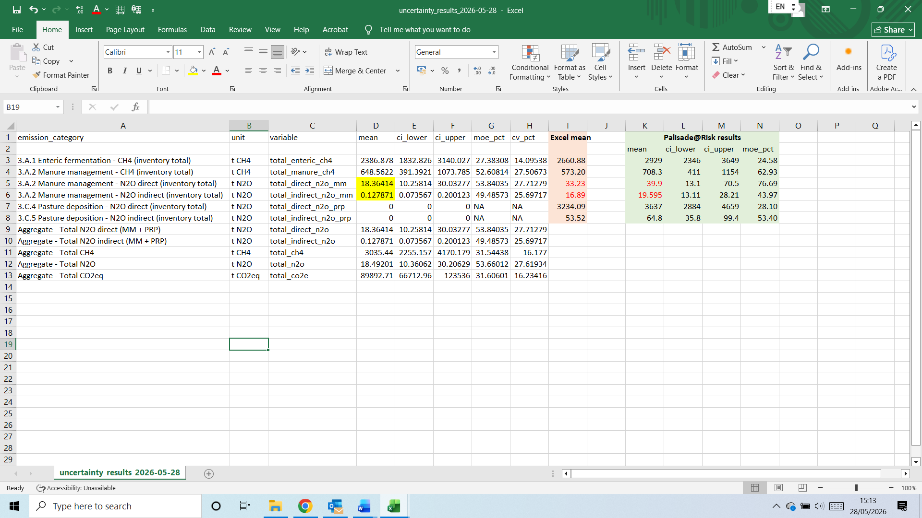
A.3 Comments on results presentation:
- It’s good to show simulated means. Units of t is OK. IPCC-compliant would be to use the units kt for CH4 and for N2O, but keeping it as t means the tool also works for smaller, project-level simulation. Since users are interested in uncertainty, can the headline result bubbles also show ±x% (i.e. margin of error)? And the right hand bubble, can it show margin of error instead of CV?
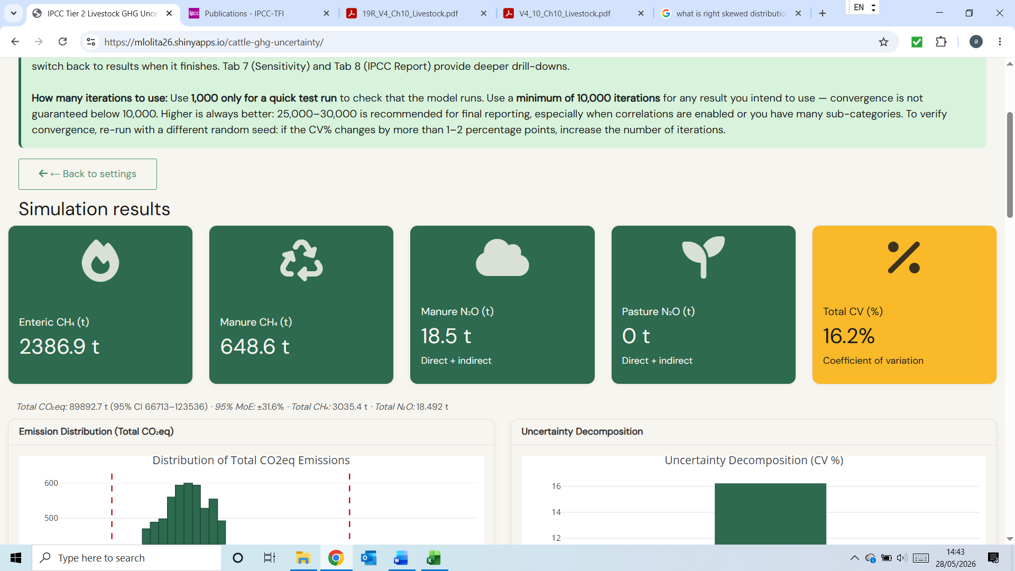
- Uncertainty decomposition: can it show margin of error instead of CV?
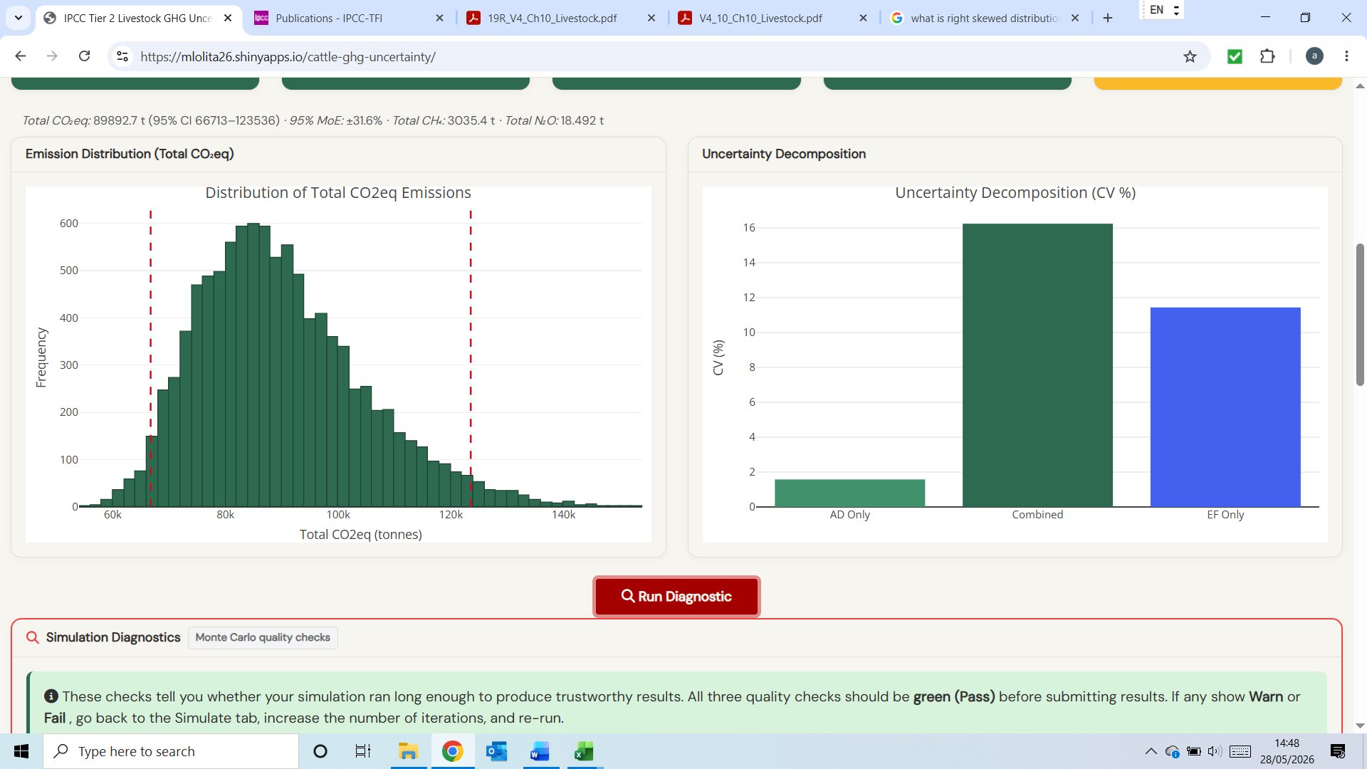
- System breakdown section gives totals per gas. Inventory users will always want to know the margins of error for each emission source (enteric, manure CH4, manure direct N2O etc) as defined in the IPCC reporting guidelines and disaggregated by dairy vs other cattle. Can this ‘breakdown’ section follow the IPCC reporting structure?
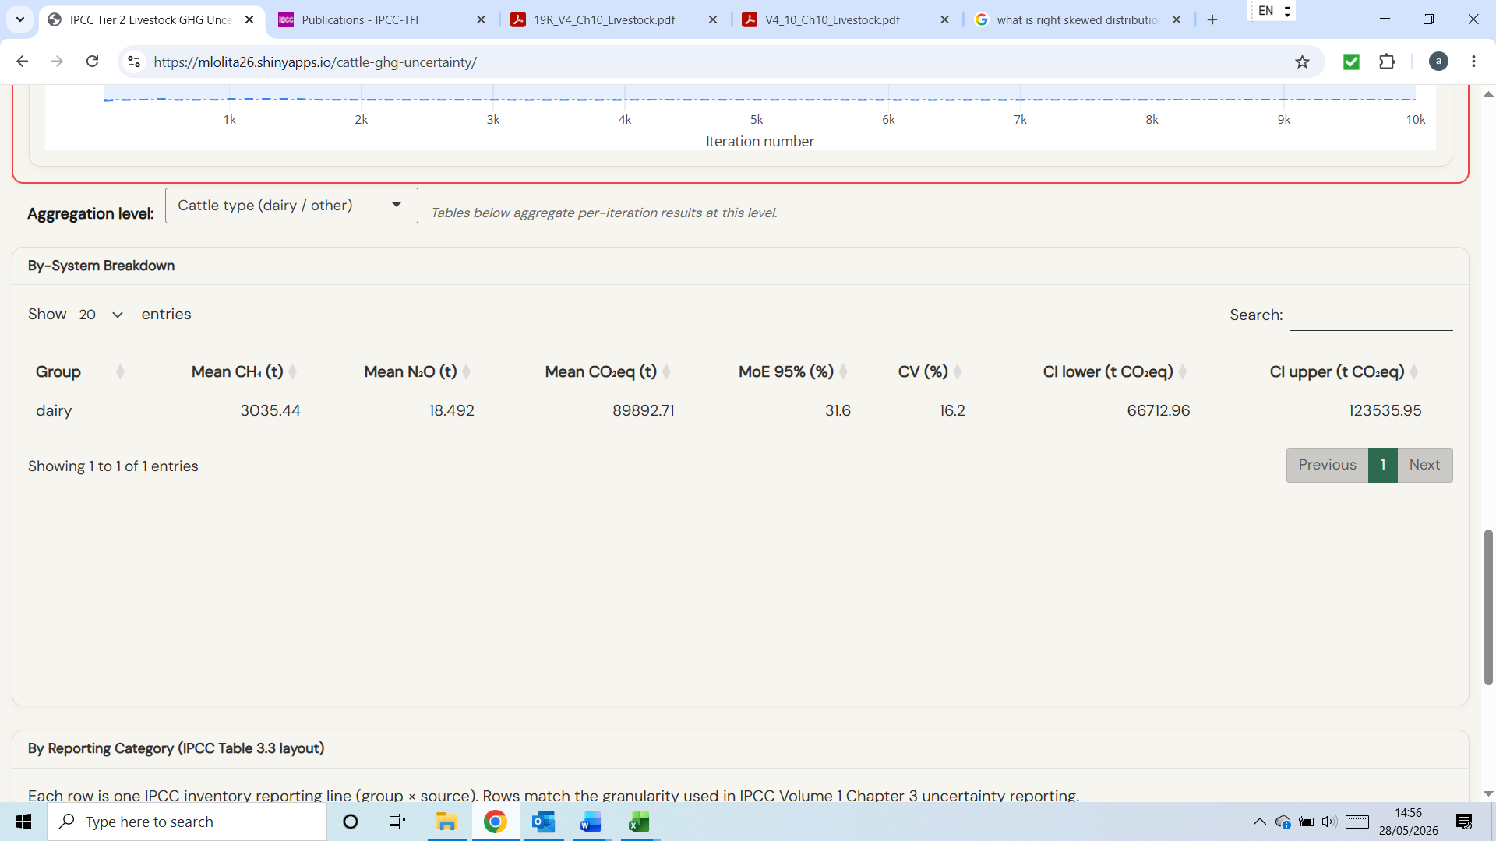
- Reporting by category section is fine, but can it give the results in t CH4 and tN2O instead of tCO2e. Inventory users will not need to CO2e results
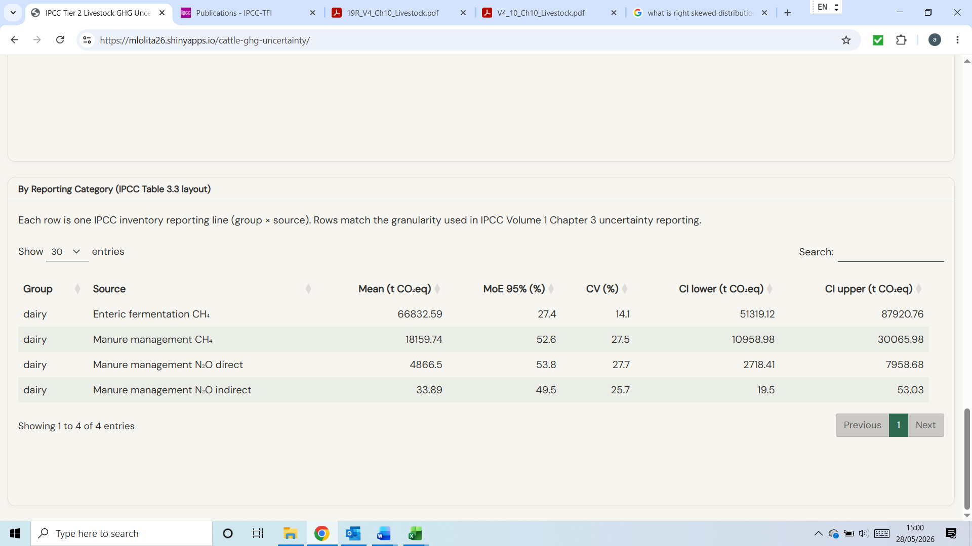
Also, I note that if one uploaded file contains both dairy cows and other cows, the system breakdown is not picked up and shown in the results, not sure why
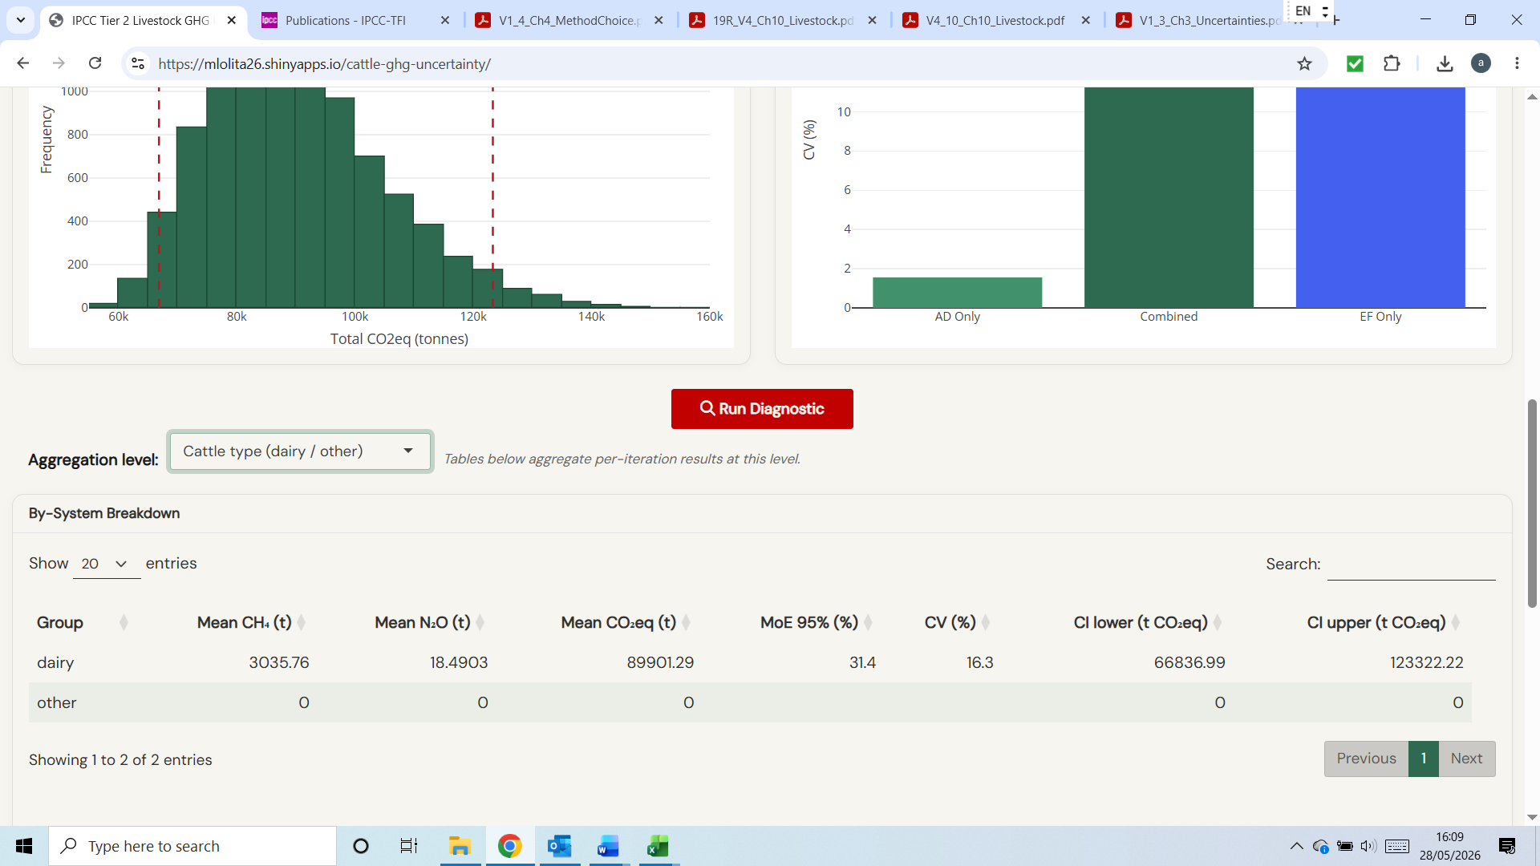
- Sensitivity results are not shown as parameters specific to a cattle sub-category
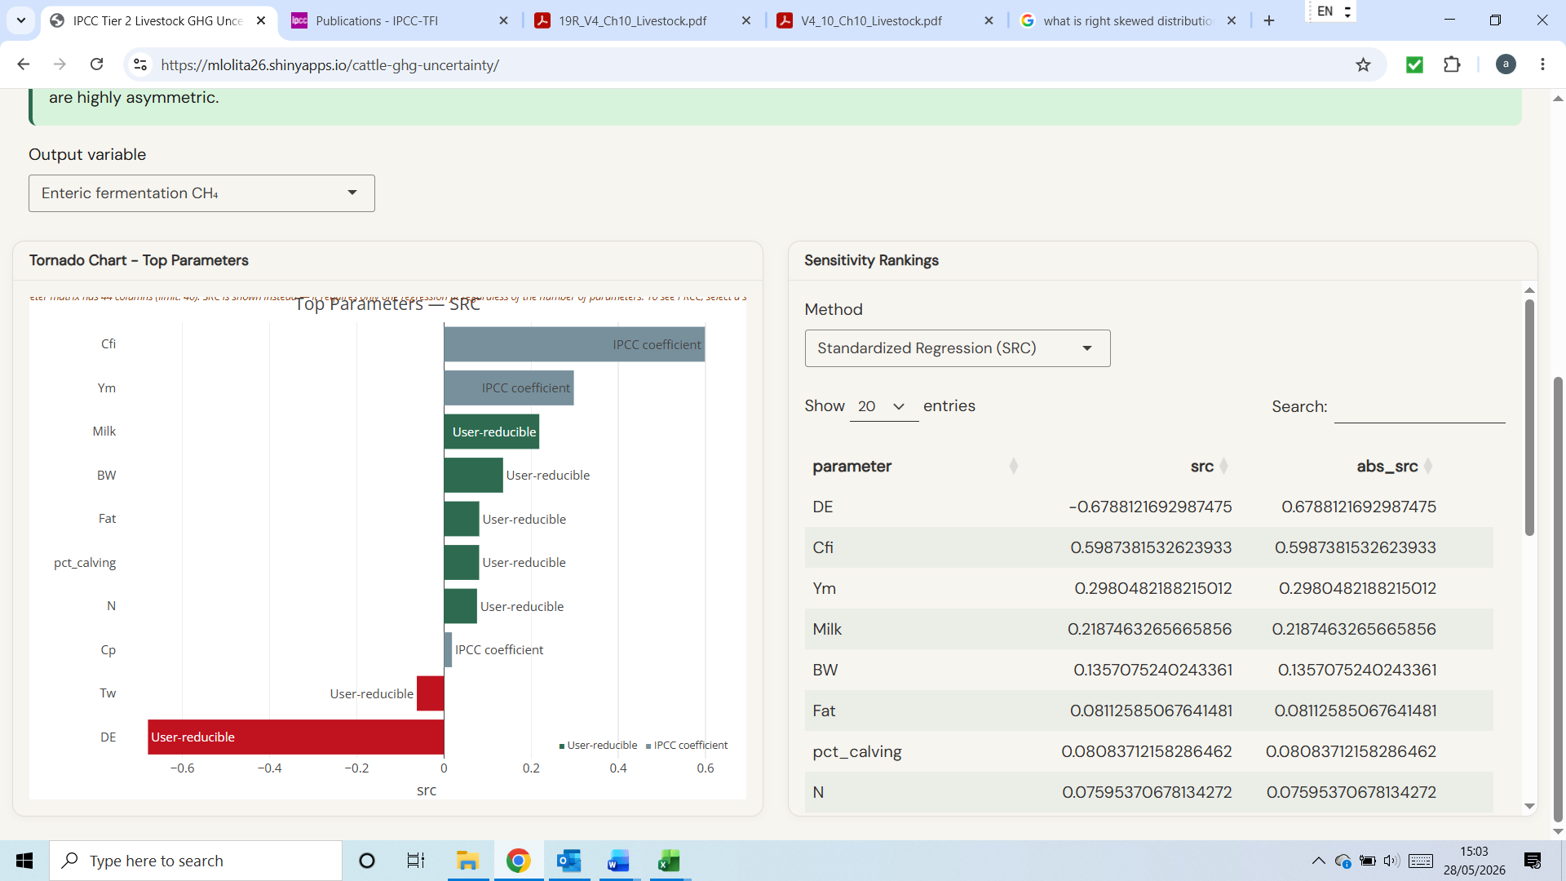

- Sensitivity results in general seem reasonable, but for manure management CH4 and N2O, MMS% never appears as a key driving variable, highlighting that there is no uncertainty input for it in the template
- IPCC report. (a) question: if the same AD is used for each emission source, why does AD uncertainty differ between emission sources? (b) The results shown are reported as %, but the word download file confirms that this is CV (%). IPCC needs margin of error expressed as a % of the mean value
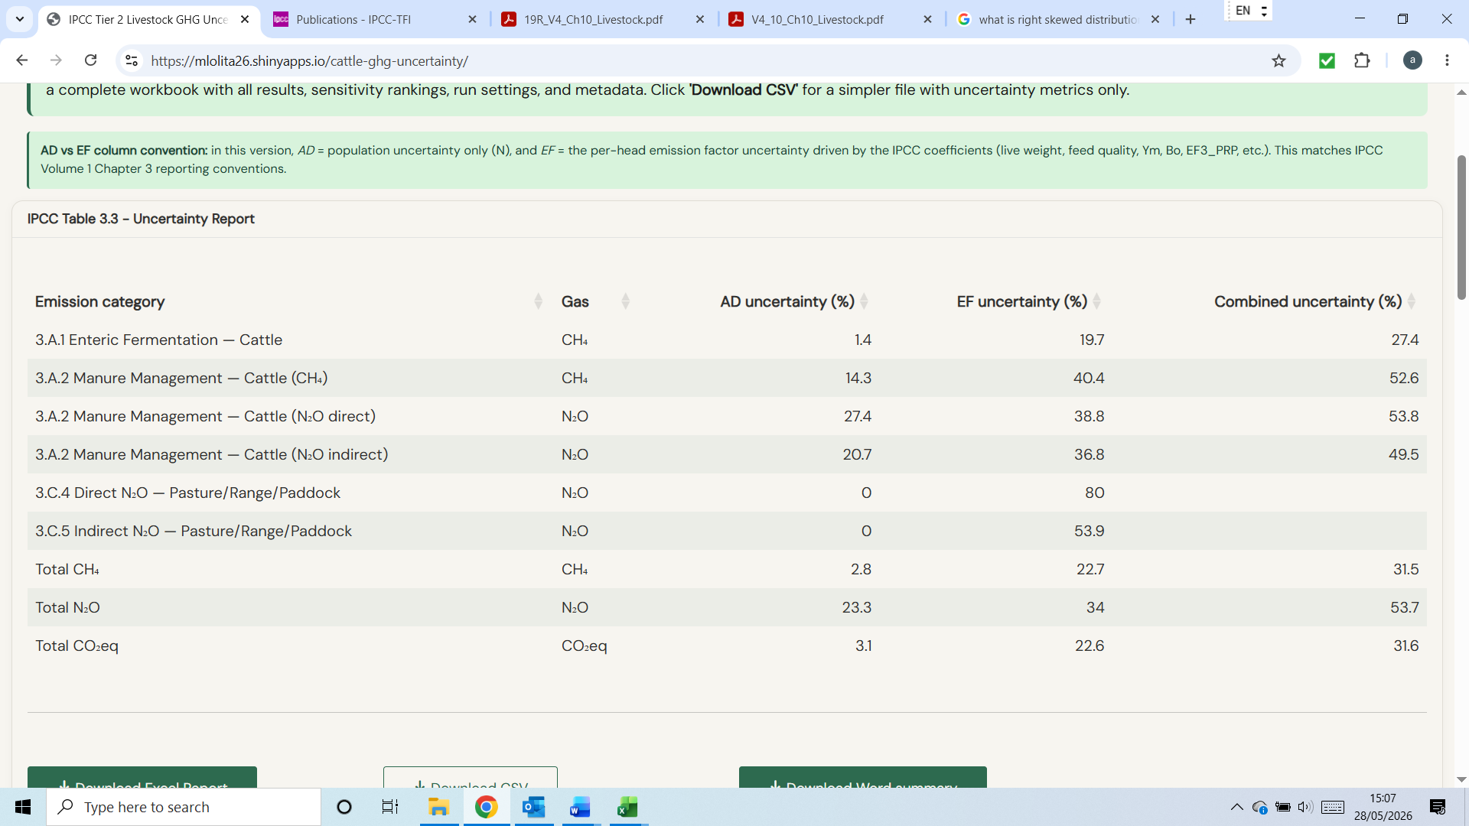

- In the downloaded excel file there were no results in the sensitivity pages, both of which stated “Sensitivity (SRC) unavailable for this run.“
IPCC compliance
- I cannot find 400 kg as the reference BW for dairy cattle in Africa in IPCC 2019
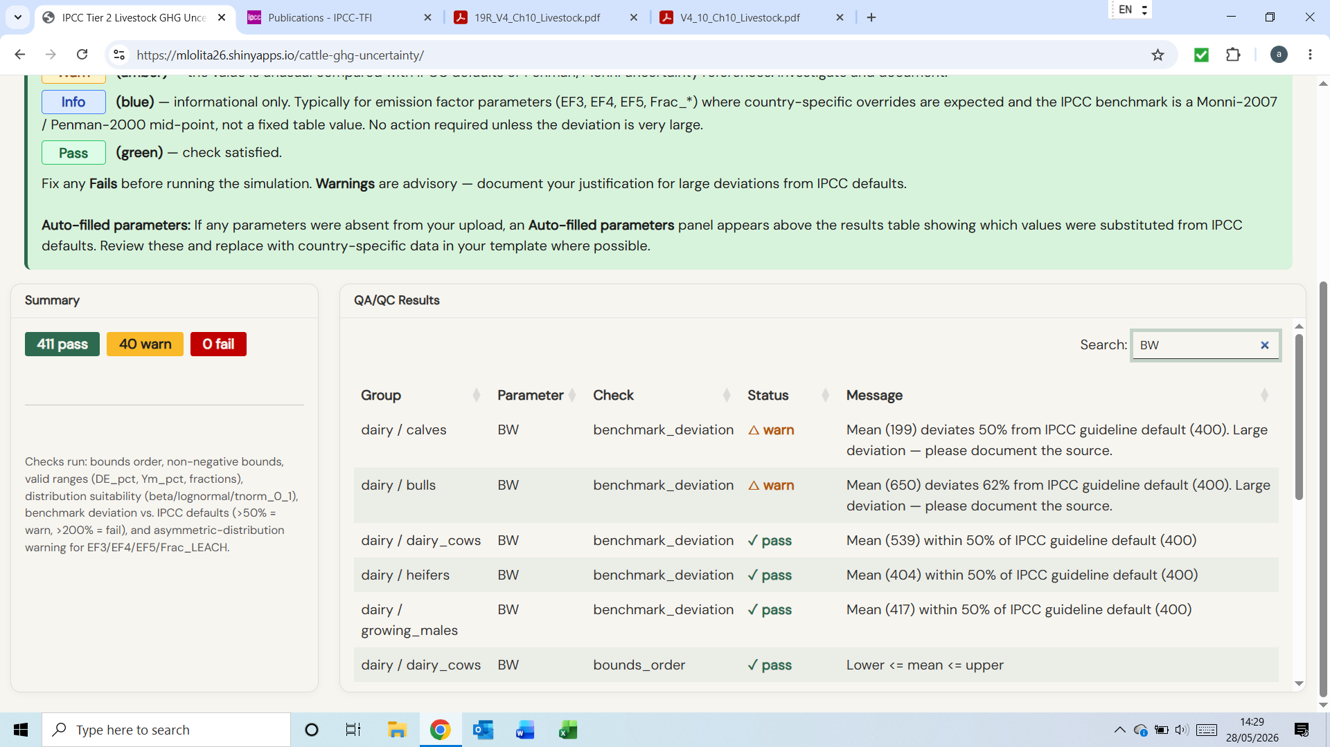
- I cannot find 300 kg as the reference MW for dairy cattle in Africa in IPCC 2019
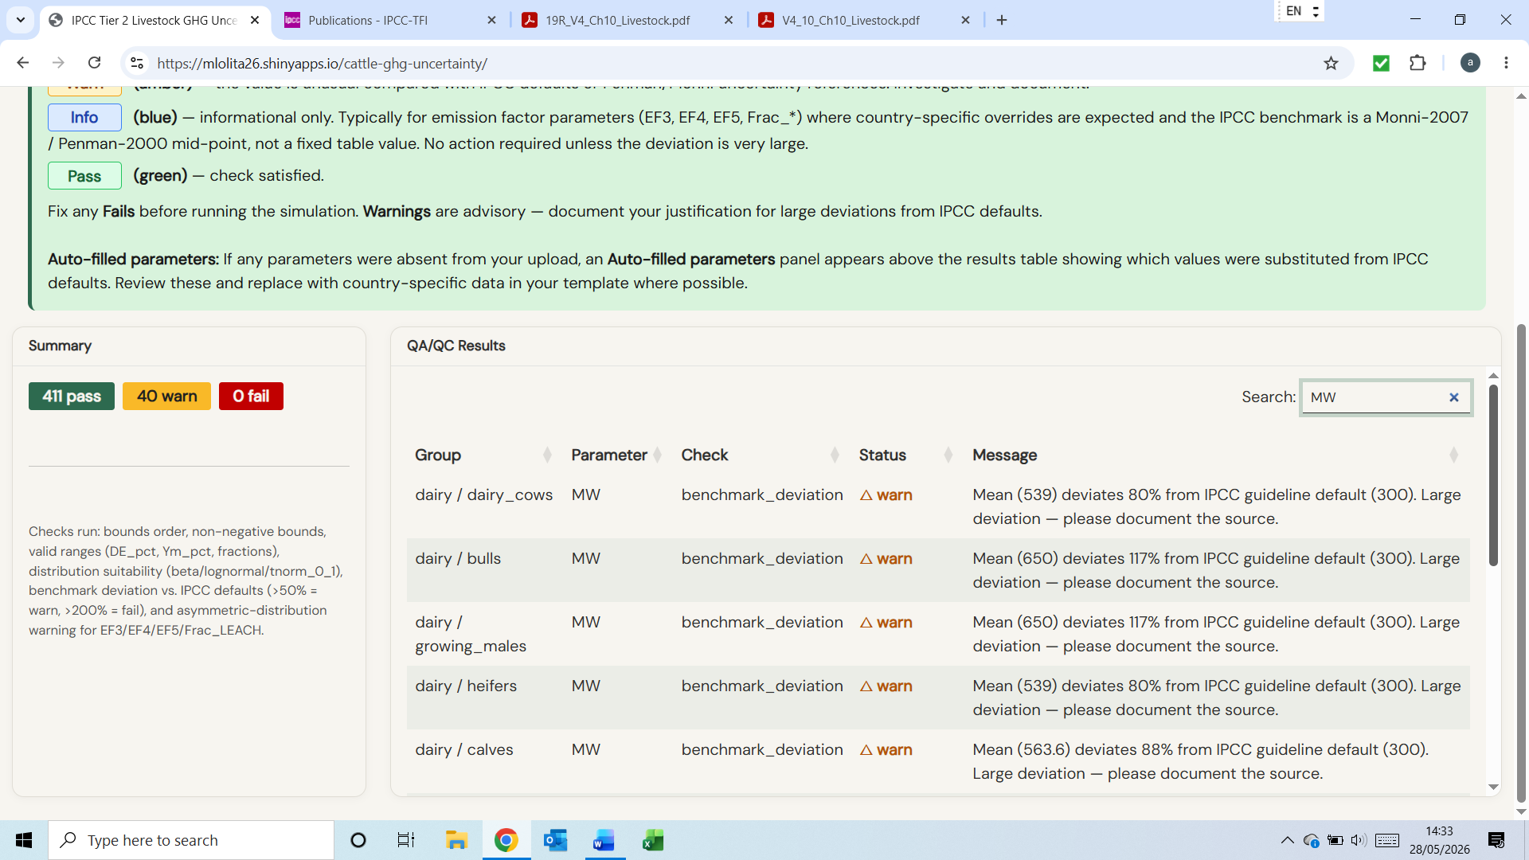
- I cannot find 10 kg as the reference milk yield for dairy cattle in Africa in IPCC 2019
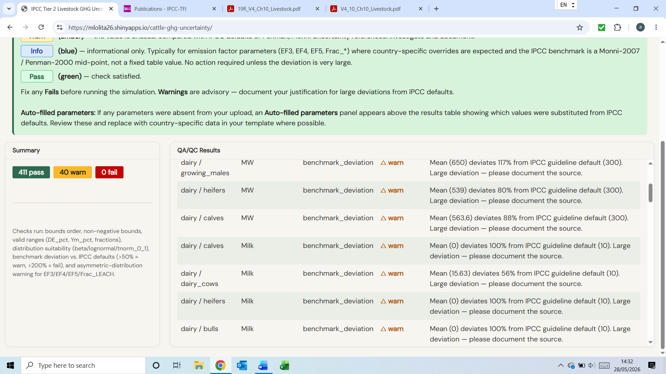
- I cannot find reference to 0.17 as the IPCC default for Bo
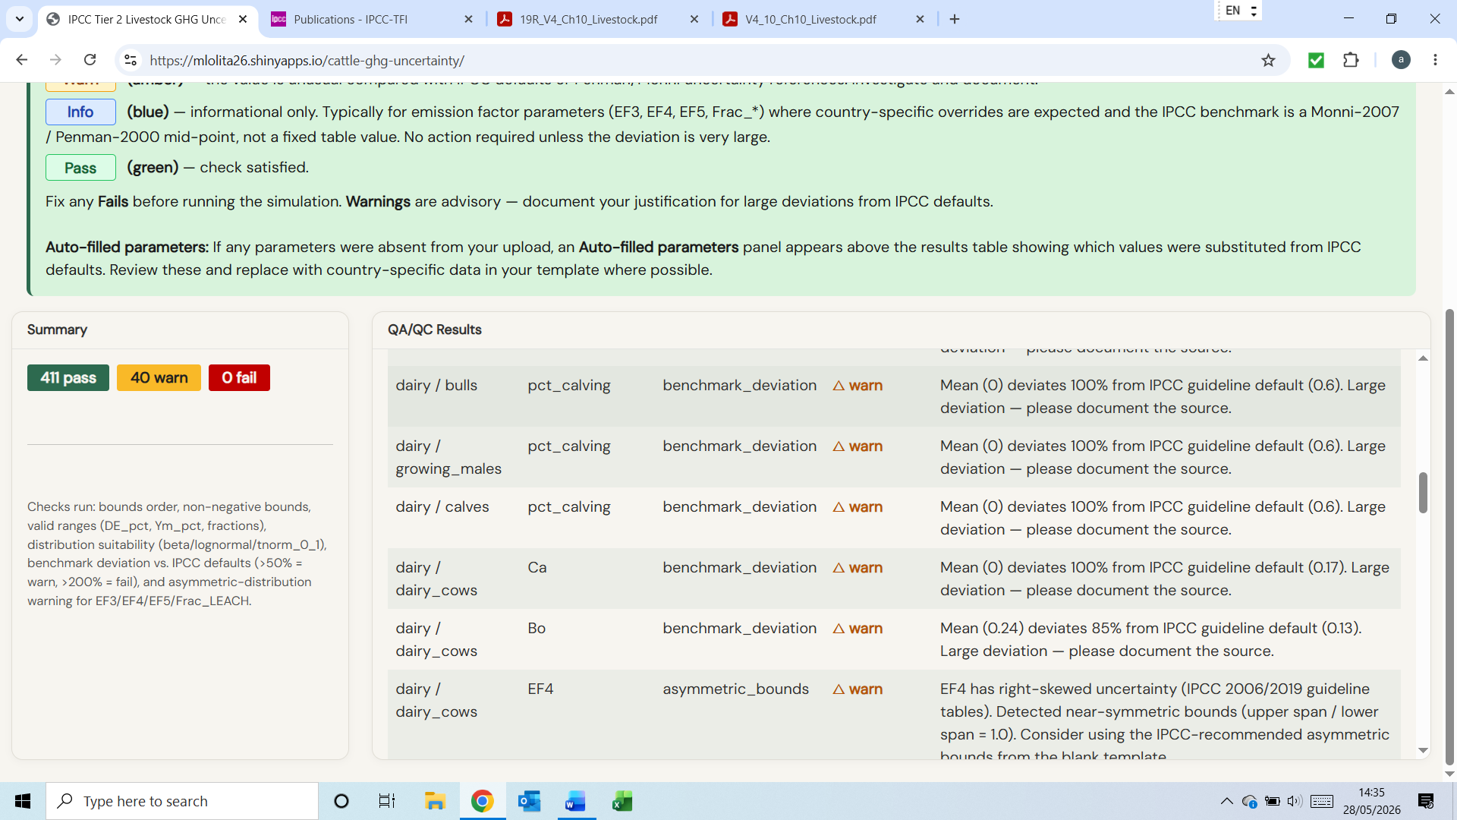
- Check the default bounds and distribution in the template for EF4 and EF5
